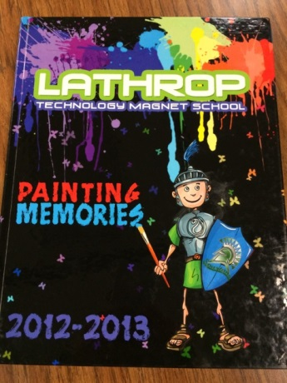****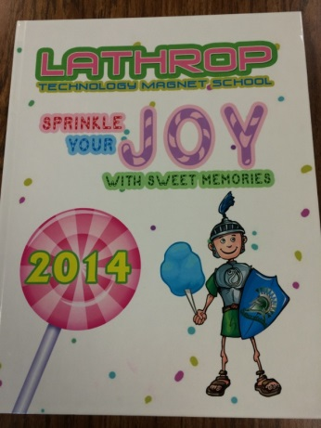

**What is Yearbook?**

* The Lathrop Yearbook represents the visual and verbal STORY of one school year in a responsible and creative way.
  + Photos and words are used to tell the story
  + The story of the year focuses on people and events that take place here at Lathrop on and off campus.

**Why is Lathrop Yearbook Special?**

* Lathrop students volunteer/select the yearbook elective to create and design the yearbook pages.
  + Students experience the use of various technology
    - FotoFusion-Yearbook design program
    - Use of digital cameras

**What makes Yearbook fun for Lathrop students?**

Aside from being in control of the book of memories for the school, Yearbook acts as a fun creative COMMUNITY for the students.

